**Intelligent Indoor OR Outdoor Surveillance Camera with AI Detection and Programmable Relay Control**

Group 01

Tech Titans



**Project Proposal**

**Skill Development Project III – ICT3206 Bachelor of Information and Communication Technology**

**(BICT) Degree Program**

Department of Information and Communication Technology Faculty of Technology

Rajarata University of Sri Lanka Mihintale.

**Details of the Project**

Project Title : Intelligent Indoor OR Outdoor Surveillance Camera with AI

Detection and Programmable Relay Control

Group Number : 01

Group Name : Tech Titans Submission Date : 2024/06/11 Group Members :

|  |  |  |
| --- | --- | --- |
| Student Name | Index Number | Signature |
| E.M.S.M. Edirisooriya | 1297 |  |
| D.H.D. Prabhasha | 1348 |  |
| H.L.I.N. Liyanaarachchi | 1390 |  |
| P.W.D.I.M. Rodrigo | 1357 |  |
| B.K. Bandaranayake | 1383 |  |
| K.R.N. Perera | 1343 |  |
| A. Sanjayan | 1363 |  |

Supervisor Details:

Name : Ms. Malki Jayawardhana Designation : Lecturer (Temporary) Email : [msjayawa@tec.rjt.ac.lk](mailto:msjayawa@tec.rjt.ac.lk) Contact No : +94 71 270 9389 Signature :



2024/06/11

Date :

**Table of Contents**

1. Introduction 4
2. Problem Statement 4
3. Aim and Objectives 4
   1. Aim 4
   2. Objectives 4
4. Scope of the Project 5
5. Preliminary Literature Review 6
6. Methodology 7
7. Project Work Plan 9
8. Conclusion 9
9. References 9

**Table of Figures**

Figure 1 Steps 7

Figure 2 System Architecture 8

# Introduction

Home security is becoming increasingly important as technology advances. Many older security camera systems lack the flexibility and advanced features needed to handle today's security challenges effectively. This project aims to address these issues by creating an intelligent indoor or outdoor surveillance camera with AI detection and programmable relay control.

This system uses artificial intelligence, cloud technology, and a mobile app to provide a strong and comprehensive security solution. By combining smart object detection, live video streaming, video recording, and relay control, this system offers excellent monitoring and control. The development of a mobile app using Flutter ensures that users can easily interact with and manage the system from their phones.

The main goals of this project include building and setting up the ESP32-CAM hardware, implementing AI- powered object detection with YOLOv8, developing cloud-based live streaming and recording features, and creating a mobile app for easy access and control. By focusing on these goals, the project aims to deliver a reliable and user-friendly surveillance solution that meets today’s security needs.

# Problem Statement

Traditional CCTV surveillance systems face several challenges that hinder their effectiveness and accessibility. These include high costs associated with purchasing, installing, and maintaining multiple components like cameras, DVRs, and storage devices. Complex installation processes often require professional assistance, adding to the overall expense and time required. Moreover, these systems lack integrated physical relays for controlling external devices, limiting their functionality. Accessibility issues arise from the need for on-site access or proprietary software for footage viewing, while storage limitations and scalability issues further constrain their utility. Maintenance needs and downtime due to hardware or software issues compound these challenges, emphasizing the need for a more efficient and accessible surveillance solution.

# Aim and Objectives

## Aim

The aim of this project is to develop an intelligent indoor/outdoor surveillance camera system integrated with AI detection and programmable relay control, addressing the limitations of traditional CCTV systems. By leveraging IoT technology, this system aims to provide a cost-effective, user-friendly, and scalable solution for enhanced security and monitoring.

## Objectives

* + 1. Developing the ESP32-CAM WIFI IP Camera to integrate seamlessly with live streaming, recording, and relay control functionalities of the surveillance system.
    2. Integrating AI-Powered Object Detection using YOLOv8 for accurate identification and classification of objects in real-time.
    3. Enable Cloud-Based Live Streaming for remote access to the surveillance camera's live video feed with robust security measures.
    4. Implementing Video Recording Functionality allowing users to start and stop recordings from the mobile app.
    5. Implementing Remote Physical Relay Control enabling users to manage external devices (e.g., lights, alarms) remotely via the mobile app.
    6. Developing a Flutter-based Mobile Application with user-friendly interfaces for monitoring live video, receiving security alerts, and controlling connected devices.
    7. Enhance Security Alerts and Notifications with intelligent mechanisms for analyzing events and providing context-aware alerts customizable by users.

# Scope of the Project

The scope of this project encompasses the design, development, and implementation of an AI-powered ESP32- CAM WIFI IP camera surveillance system with advanced functionalities for indoor and outdoor monitoring. The primary components and functionalities to be developed include

### ESP32-CAM WIFI IP Camera

* + Design and setup of the ESP32-CAM module.
  + Integration of a 2MP camera video recording.

### AI-Powered Object Detection

* + Implementation of the YOLOv8 object detection algorithm to identify and classify objects in real-time.
  + Optimization of the AI model to ensure efficient and accurate object detection within the camera's field of view.

### Cloud-Based Live Streaming

* + Development of a secure cloud-based solution for streaming live video feeds.

### Video Recording and Playback

* + Development of functionality to start and stop video recordings from the mobile application.
  + Storage of recorded videos on the ESP32-CAM's SD card or optionally on the user's mobile device.
  + Implementation of playback features within the mobile application for reviewing recorded footage.

### Programmable Physical Relay Control

* + Design and implementation of a dual relay module to control external devices (e.g., lights, alarms, locks).
  + Integration of relay control within the mobile application, allowing users to remotely manage connected devices.
  + Configuration of automation rules to trigger relay actions based on detected events or manual commands.

### Flutter Mobile Application

* + Development of a cross-platform mobile application using the Flutter framework.
  + Implementation of user-friendly interfaces for monitoring live video feeds, receiving alerts, and controlling Physical Relays.

### Security Alerts and Notifications

* + **Restricted Area Intrusion:** Users can enable "Restricted Area Alerts" to receive notifications when YOLOv8 detects people in designated off-limit zones.
  + **Pet Pets/Wildlife:** Identify pets or wild animals entering certain areas. The system triggers "Animal Detection Alerts" when YOLOv8 identifies unwanted animals in areas where they could cause harm.
  + **Baby Monitor:** Enable "Baby Out-of-Frame Alerts" to be notified if the camera doesn't detect your baby within the frame for a set duration.
  + **Package Delivery Detection:** Get notified with "Package Arrival Alerts" upon object detection consistent with package delivery by YOLOv8.
  + **Smart Relay Control:** Program the mobile app to trigger physical relays (lights, alarms) upon detection of user- defined objects through YOLOv8.
  + **Customizable Object Alerts:** The app allows users to define custom "Text-Based Object Alerts" for any object YOLOv8 detects.

### System Testing and Validation

* + Comprehensive testing of all system components to ensure functionality, performance, and reliability.
  + Validation of AI object detection accuracy and relay control responsiveness.
  + User testing to gather feedback and make necessary adjustments for optimal user experience.

### Residential Focus:

* + **Primary Use Case:** This camera system is designed primarily for residential environments. It aims to provide homeowners with a reliable and affordable surveillance solution.

### Dual Mode Operation (Indoor and Outdoor):

* + Users can easily switch between indoor and outdoor modes via the mobile app. This ensures optimal performance and accuracy in object detection and monitoring based on the specific environment where the camera is deployed.

By addressing these components, the project aims to deliver a robust, intelligent, and user-friendly surveillance solution that enhances security and provides convenient remote management capabilities. The successful implementation of this system will offer significant improvements over traditional surveillance systems, making it suitable for residential applications

# Preliminary Literature Review

The rapid advancements in technology have significantly influenced the domain of home security, transitioning from basic surveillance systems to intelligent solutions that leverage AI and IoT (Internet of Things). This review explores the key technologies, methodologies, and existing research relevant to developing an AI-powered ESP32-CAM WIFI IP camera surveillance system.

### AI-Powered Object Detection

* + **YOLO (You Only Look Once) Algorithm**: The YOLO family of algorithms represents a paradigm shift in object detection, emphasizing speed and accuracy. YOLOv8, the latest iteration, continues this tradition by integrating several enhancements that facilitate real-time detection and classification of objects within video feeds. Studies demonstrate YOLOv8's superior performance in various applications, making it a preferred choice for security systems where rapid and accurate object detection is crucial (Bochkovskiy et al., 2020; Redmon & Farhadi, 2018).
  + **Edge AI**: Deploying AI models on edge devices like the ESP32-CAM is becoming increasingly feasible due to advancements in lightweight model architectures and edge computing capabilities. Edge AI minimizes latency, reduces bandwidth usage, and enhances privacy by processing data locally (Zhang et al., 2021). Research highlights successful implementations of edge AI in surveillance, emphasizing its benefits over cloud-based processing.
  + ​

### Cloud-Based Live Streaming and Video Recording

* + **Cloud Computing in Surveillance**: Cloud-based surveillance solutions offer scalability, remote accessibility, and enhanced data management capabilities. These systems can handle large volumes of video data and provide robust storage solutions, ensuring that users can access their footage from anywhere (Luan et al., 2015). Secure cloud protocols are essential to protect the privacy and integrity of the streamed content, with encryption mechanisms playing a critical role (Gupta et al., 2018).
  + **Integration Challenges**: While cloud integration offers many advantages, it also poses challenges such as ensuring real-time performance and maintaining data security. Research indicates that optimizing data transmission and employing advanced encryption standards are effective strategies to address these challenges (Albahar et al., 2019).
  + ​

### Mobile Application Development

* + **Flutter Framework**: Flutter has emerged as a popular framework for developing cross-platform mobile applications due to its high performance and expressive UI capabilities. Its single codebase approach significantly reduces development time and effort while ensuring consistent performance across different platforms (Xing, 2020). Research indicates that Flutter is well-suited for developing interactive and real-time applications like surveillance system interfaces (Meng et al., 2020).
  + **User Interface and Experience**: Designing an intuitive and user-friendly mobile interface is critical for the adoption and effectiveness of surveillance systems. Studies emphasize the importance of responsive design, easy navigation, and real-time feedback in enhancing user experience (Nielsen & Budiu, 2013). The Flutter framework’s capabilities align well with these requirements, enabling the creation of seamless and engaging user interfaces.
  + ​

### Programmable Relay Control

* + **Relay Modules in IoT**: Relay modules allow remote control of various electrical devices, integrating seamlessly with IoT applications. Research highlights the effectiveness of relay modules in automating security responses, such as activating alarms or locking doors in response to detected events (Kumar et al., 2016). The integration of programmable relay control with surveillance systems enhances their functionality and responsiveness.
  + **Automation and Security**: Implementing automation rules based on AI-detected events improves the responsiveness and reliability of surveillance systems. Studies show that automated responses can significantly reduce the time to react to security incidents, providing a proactive approach to security management (Zhou et al., 2019).

# Methodology

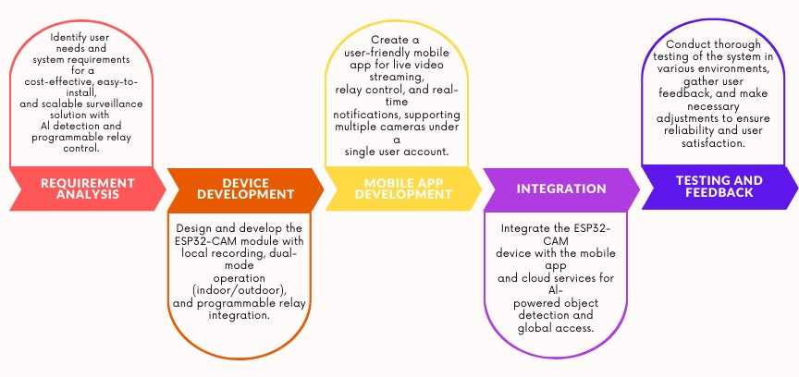

*Figure 1 Steps*

#### *Hardware Components,*

* + ESP32 development bord,
  + ESP32-CAM with OV2640 2MP camera sensor
  + FTDI USB to Serial converter (for programming) + Female-to-female jumper wires
  + 4GB MicroSD card (TF Card)
  + Clip-on antenna
  + TP4056 1-cell Li-Ion Charging module
  + 18650 3.7V 2600mAh battery (x2)
  + Mini SPDT sliding switch.
  + Some 24-gauge electrical wire
  + 3mm Red LED
  + 220 Ohm resistor
  + 3D printed plastic container.
  + Relay moule

### Software Components,

* **Flutter:** Utilize Flutter to develop beautiful and performant mobile applications for Android platforms.
* **Figma:** Design user interfaces for the Flutter app using Figma, a powerful and collaborative design tool. Figma allows for seamless collaboration among team members and facilitates the creation of visually appealing UI designs.
* **Firebase Authentication:** Seamlessly integrate user authentication and signup functionality into the Flutter app using Firebase Authentication.
* **Firebase Cloud Messaging:** Send real-time notifications to app users using Firebase Cloud Messaging. Keep users engaged and informed by sending timely notifications directly to their devices, enhancing user experience and interaction with the app.

### Cloud Components,

* **Google Cloud VM (Free trial):** Utilize Google Cloud Virtual Machine for building a secure and scalable backend infrastructure. Google Cloud VM offers flexibility and reliability, making it ideal for hosting the backend services of the surveillance system.
* **YOLOv8:** Implement YOLOv8, a powerful object detection tool, for pinpointing objects in images and videos with lightning speed. YOLOv8's advanced capabilities enable real-time object detection, enhancing the surveillance system's efficiency and accuracy.
* **Python Security Algorithm:** Develop a custom Python security algorithm to augment the surveillance system's capabilities. This algorithm will be integrated into the system to enhance security measures and provide additional layers of protection against potential threats and intrusions.

### System Architecture,

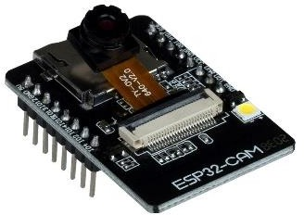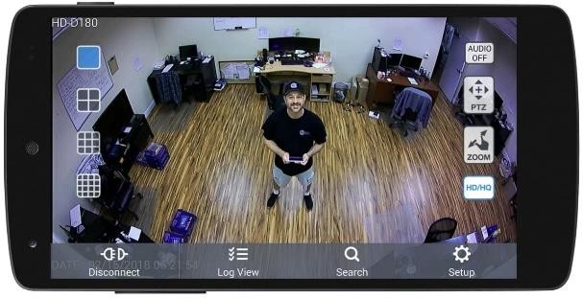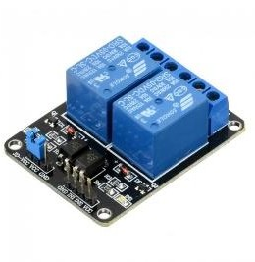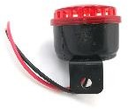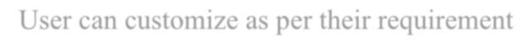

Google Cloud

Programable relay module

Google Cloud(vm)

ESP32 + Cam Module

**Flutter Mobile Application**

Firebase (Authentication service)

Out of our Project boundary

User can customize as per their requirement

# Project Work Plan

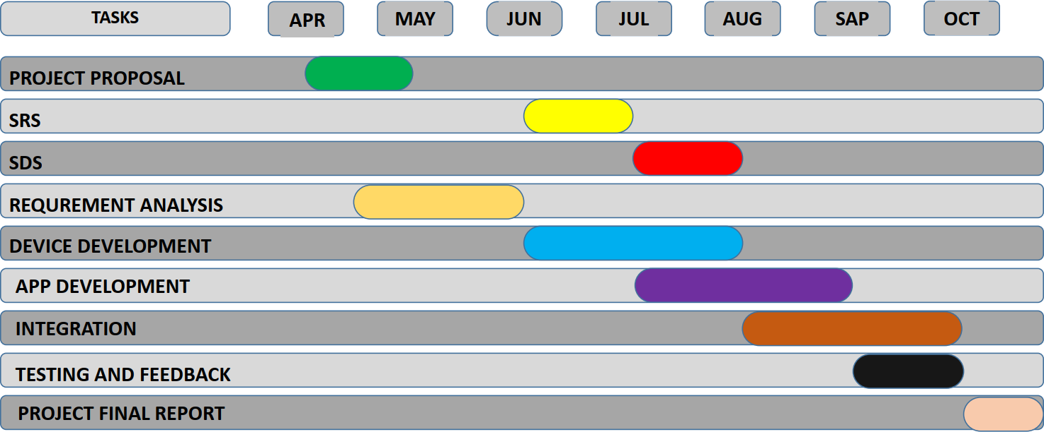

# Conclusion

The proposed project aims to revolutionize traditional surveillance systems by integrating AI-powered object detection, cloud-based services, and mobile applications. It integrates the ESP32-CAM WIFI IP camera with YOLOv8 for real-time object detection and offers cloud-based live streaming, recording, playback, and programmable relay control. A Flutter-based mobile app enhances user convenience and security. The project addresses limitations of conventional CCTV systems, such as high costs, false alarms, limited functionality, and inconvenient access. It provides intelligent notifications, remote control capabilities, and advanced monitoring features, improving security for residential applications. This project sets a new standard for future surveillance technologies, demonstrating the integration of AI and IoT technologies in everyday security challenges.

# References

* + A. Bochkovskiy, C. Y. Wang, and H. Liao, "YOLOv4: Optimal Speed and Accuracy of Object Detection," *arXiv preprint arXiv:2004.10934*, 2020.
  + J. Redmon and A. Farhadi, "YOLOv3: An Incremental Improvement," *arXiv preprint arXiv:1804.02767*, 2018.
  + Z. Zhang, L. Xu, and S. Fu, "Edge Computing and Artificial Intelligence in Internet of Things," *IEEE Communications Magazine*, vol. 59, no. 2, pp. 66-72, 2021.
  + T. Luan, L. Gao, Z. Li, Y. Xiang, and L. Sun, "Fog Computing: Focusing on Mobile Users at the Edge," in *Proc. of the IEEE International Conference on Networking, Architecture, and Storage (NAS)*, 2015, pp. 1-5.
  + R. Gupta, A. Tewari, and A. Gaur, "Data Security and Privacy in Cloud Computing: Issues and Current Solutions," *International Journal of Advanced Research in Computer Science*, vol. 9, no. 1, pp. 259-266, 2018.
  + R. Albahar, H. T. Mouftah, and M. Erol-Kantarci, "Real-Time and Secure Video Surveillance over Cloud," *IEEE Access*, vol. 7, pp. 35853-35863, 2019.
  + X. Xing, "Flutter for Cross-Platform App Development: A Developer's Perspective," *Journal of Software Engineering and Applications*, vol. 13, no. 4, pp. 194-201, 2020.
  + X. Meng, Y. Liu, and H. Zhang, "Development of a Real-Time Surveillance System Using Flutter," in *Proc. of the IEEE International Conference on Information Technology and Applications (ITA)*, 2020, pp. 324-329.
  + J. Nielsen and R. Budiu, *Mobile Usability*, 1st ed. New Riders, 2013.
  + P. Kumar, A. Rana, and N. R. Prasad, "Relay Modules for IoT Applications: A Review," *International Journal of Advanced Research in Electrical, Electronics and Instrumentation Engineering*, vol. 5, no. 5, pp. 4571-4578, 2016.
  + F. Zhou, Y. Liu, and K. Zhang, "Automation in IoT-Based Surveillance Systems," *IEEE Internet of Things Journal*, vol. 6, no. 2, pp. 2101-2111, 2019.